

10 Science **GENETICS** Term 1 Practice Test

**1.** DNA can be described as

**A.** an expression of a trait

**B.** a strand of protein that attacks foreign antigens

**C.** a sequence of bases on a sugar-phosphate backbone

**D.** a single stranded unit composed of sugar, phosphate, and a base

**2.** Alternate forms of the same gene are known as

**A.** alleles

**B.** gametes

**C.** genotypes

**D.** heterozygotes

**3.** The process that produces gametes (sex cells) in the reproductive organs is called

**A.** mitosis

**B.** meiosis

**C.** fertilization

**D.** DNA replication

Use the following information to answer Question 7:

One strand of a small segment of DNA has the sequence

**A - A - T - C - T - C - G - T - A**

**4.** The sequence of the complementary strand is

**A.** G - G - C - T - C - T - A - C - G

**B.** T - T - A - G - A - G - C - A - T

**C.** C - C - G - A - G - A - T - G - C

**D.** A - A - T - C - T - C - G - T – A

**5.** In a sample of bacteriaDNA, the percentage of the nucleotide base molecules that are adenine (**A**) is 23.6%. The expected percentage of nucleotide base molecules that would be thymine (**T**) is

**A.** 76.4%

**B.** 38.2%

**C.** 23.6%

**D.** 11.8%

Use the following information to answer Questions 15 and 16:

*A condition called “situs inversus” causes the internal organs of an animal to be reversed, and end up on the wrong side of the body. Scientists have shown that insertion of a particular allele in mice may lead to this condition. Mice that are* ***homozygous*** *for this inserted allele are born with their organs reversed, and die within a week of their birth. Mice that are heterozygous for this inserted allele are born with their organs in normal positions.*

**6.** It is most likely that the “situs inversus” allele in mice is

**A.** dominant

**B.** recessive

**C.** inactive

**7.** If two **heterozygous** mice were mated, what percentage of their offspring would be predicted to die?

**A.** 0%

**B.** 25%

**C.** 50%

**D.** 75%

**9.** In Foxes, the gene for red coat colour **(R**) is dominant to the gene for silver-black colour (**r**). Determine the genotype and phenotype percentages/ratios expected for the cross between a silver-black coat male with a heterozygous red female.

**10.** Colour blindness in humans is a **sex-linked** characteristic. A dad who was colour-blind and a mum who was a carrier for colour-blindness had 2 children, one boy and one girl.

* 1. What is the chance the boy will be colour-blind? Explain using a punnet square
  2. What is the chance the girl will be colour-blind? Explain using a punnet square

**8.** Write the word that best describes the statement on the left side

|  |  |  |
| --- | --- | --- |
| (a) | Reproduction requiring only one parent |  |
| (b) | Reproduction requiring two parents |  |
| (c) | Short length of chromosome (DNA) which determines a particular characteristic |  |
| (d) | Number of chromosomes in a normal human cell |  |
| (e) | Number of chromosomes in a human gamete - sperm or egg cell |  |
| (f) | When a gene is “masked” or “hidden” |  |
| (h) | When a gene “masks” or “hides” an alternative gene |  |
| (i) | Different genes for the same characteristic |  |
| (j) | Identical genes for the same characteristic |  |

(4.5 marks)

**11.** Alkaptonuria or Maple Syrup disease is a rare genetically inherited disease found in humans. In this disease the urine contains a substance which gives it a dark brown colour which turns black on exposure to air. The family tree below shows a family containing some individuals who have Alkaptonuria (shaded).

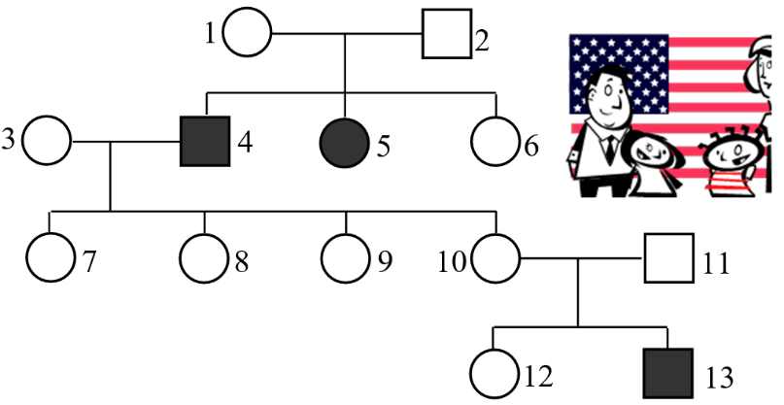(a) Is alkaptonuria dominant or recessive? Explain your reasoning.

(b) Determine the genotype of individuals 1, 4, 10, and 11.

**12.** Consider the pedigree for the inheritance of “faulty tooth enamel”

1. State how many generations are shown in the pedigree
2. Identify the phenotype of individual II2, II4 and II8
3. Identify the relationship between individual II5 and III7
4. Write down the genotypes for all even numbered individuals.
5. Identify if this a dominant or a recessive disorder, and explain how you know this.
6. Does individual I1 have a heterozygous or a homozygous genotype? Justify your answer.

**13.** Down below Tasmania, there is an island called Bleak Island, home to a unique species of penguins called snow penguins. Most snow penguins are white although a small percentage are grey. Scientists believe this is because the penguin hatch (from eggs) when there is snow cover on the ground. The white hatchlings are better camouflaged than the grey hatchlings, and are therefore better protected from birds of prey. Most of the white hatchlings survive, but most of the grey hatchlings are preyed upon and do not survive.

However, the climate on Bleak Island is changing, and in the last few years, the penguins have been hatching when there is no snow cover. Use your knowledge of Darwin’s theory of evolution by Natural Selection to describe how you would expect the penguin population to change.